Project Design Phase-II
Technology Stack (Architecture & Stack)

Date | 31 July 2026
Team ID | Vemuri Gayathri
Project Name | Metro Ticket Generating System in ServiceNow
Maximum Marks | 4 Marks

Technical Architecture:
The Deliverable shall include the architectural diagram as below and the information as per the table1 & table 2
Example: Order processing during pandemics for offline mode

Guidelines:
1.Map Core Application Logic: Draw distinct process blocks for key workflows like the Ticket Engine, QR Code Generator, and WhatsApp Bot Service.
2. Define Environment Demarcations: Clearly divide components using boundaries (e.g., Client Side / Local Devices vs. ServiceNow SaaS Cloud Infrastructure).
3. Include Data Storage Components: Show dedicated database and storage blocks for system databases, active ticket transaction stores, and attachments.
4. Identify External API Interfaces: Connect third-party services such as UPI Payment Gateways, WhatsApp Cloud APIs, and physical AFC Gate Scanners.
5. Integrate Analytics / AI Modules: Map direct connections to machine learning and reporting services like ServiceNow Predictive Intelligence and Performance Analytics.
6. Show Data Flow Direction: Use directional arrows to clearly demonstrate how requests, payments, and QR verifications flow between users, cloud services, and hardware gates.

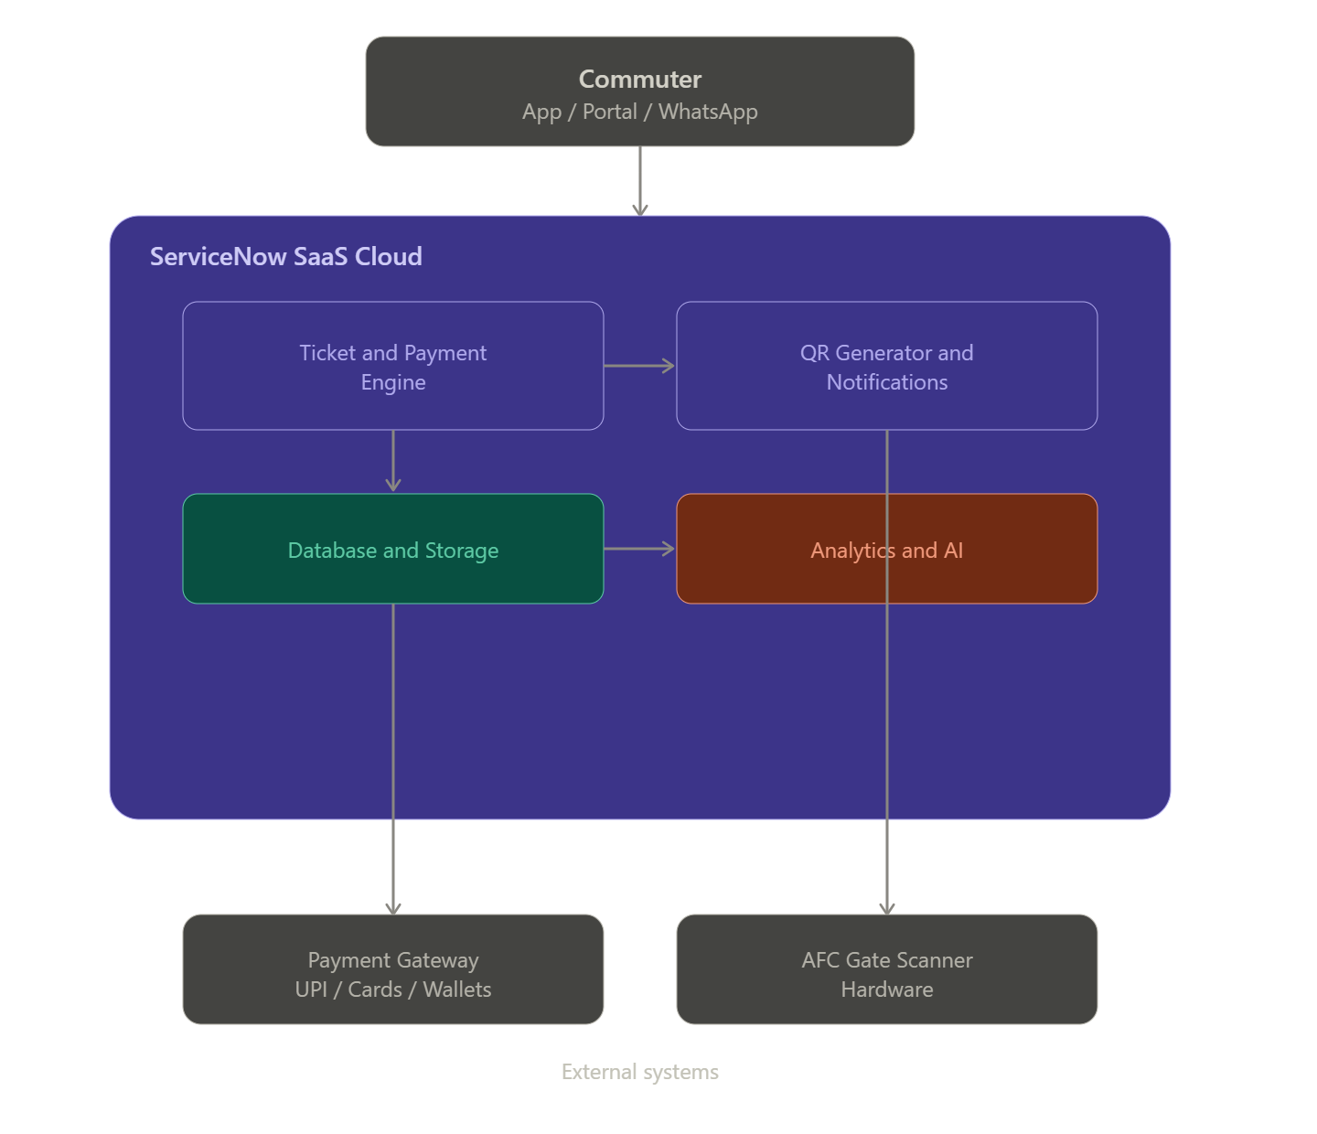

Table-1 : Components & Technologies:
S.No | Component | Description | Technology
1. | User Interface | Service Portal & Mobile App for commuters to select routes and purchase tickets | ServiceNow Service Portal, HTML5, CSS3, JavaScript (AngularJS / Widget Framework)
2. | Application Logic-1 | Ticket Processing Engine for fare calculation, ticket issuance, and status tracking | ServiceNow Flow Designer, Business Rules, JavaScript (GlideAPI)
3. | Application Logic-2 | Dynamic QR Code Generator Service to create scan-ready entry/exit passes | ServiceNow Script Includes, QR Code Generation Library (JS / Google Chart API / Node module)
4. | Application Logic-3 | WhatsApp Interactive Bot Workflow for conversational ticket booking | ServiceNow Virtual Agent, IntegrationHub Webhook listener
5. | Database | Platform database storing user records, fare masters, active tickets, and transaction logs | ServiceNow Relational Database (MariaDB / MySQL backend managed by ServiceNow platform)
6. | Cloud Database | High-speed cache / transactional store for real-time QR gate validation logs | ServiceNow Cloud Database Services
7. | File Storage | Storage for QR code image assets and generated ticket PDF invoices | ServiceNow Sys_Attachment Table / Cloud Attachment Storage
8. | External API-1 | Digital Payment Gateway Integration for UPI, Cards, and Wallet payments | REST APIs (Razorpay / Paytm / Stripe APIs via IntegrationHub)
9. | External API-2 | WhatsApp Messaging API Integration for sending dynamic QR tickets to WhatsApp | WhatsApp Business Cloud API / Twilio Messaging API
10. | Machine Learning Model | Predictive passenger analytics for peak rush hour forecasting | ServiceNow Predictive Intelligence / Performance Analytics
11. | Infrastructure | Multi-tenant Cloud Infrastructure managed on ServiceNow enterprise SaaS cloud | ServiceNow Enterprise SaaS Cloud / AWS Multi-AZ Deployment

Table-2: Application Characteristics:
S.No | Characteristics | Description | Technology
1. | Open-Source Frameworks | Frontend rendering frameworks and client-side web components | AngularJS, Bootstrap 3/4, Node.js QR Libraries
2. | Security Implementations | End-to-end data encryption, HTTPS protocols, and access control policies | SHA-256 Encryption, OAuth 2.0, TLS 1.3, ServiceNow ACLs
3. | Scalable Architecture | Enterprise multi-tier architecture to handle high concurrent booking traffic | ServiceNow High Availability (HA) & REST/SOAP IntegrationHub
4. | Availability | Continuous active-active server deployment for 24/7 uptime | ServiceNow Advanced High Availability (AHA) Architecture
5. | Performance | In-memory caching and asynchronous scripting for sub-second gate validation | ServiceNow In-Memory Cache, Indexed DB, ServiceNow CDN

